Web Development (Intermediate)
WEDE6021
POE : Part 1



Group Members:
Armalene Magerman : ST10454097
Chloe Langenhoven: ST10435895
Rafiqah Kirby: ST10438554

Due date : 14 April 2026

SECTION 2 – Planning and Design

Table of Contents
Introduction 3
Brief overview of our planned web application including our innovative features. 3
Innovative Features: 3
List of functions 4
1. Login and User Registration 4
2. Verification of Sellers 4
3. List of Products 4
4. System of Administrative Approval 4
5. Browsing Products 4
6. Filtering and Searching 4
7 .Purchasing Cart 4
8.The System of Checkout 5
9. System of Messaging 5
10 .Management of Administration 5
User interface design 5
Sitemap for Web Application. 6
Detailed listing of the data captured from the seller and buyer and store in the MySQL database. 6
Data Captured from Buyers 6
Data Captured from Sellers: 7
Data Captured from Admin 7
Actors and their role in the system 8
ERD diagram 8
Project plan detailing deadlines and milestones 9
﻿﻿﻿Conclusion 9
References 10

Introduction
This section's goal is to provide a thorough blueprint and design for the suggested Pastimes web application, an online marketplace for the purchase and sale of used items. In web development, careful planning is essential because it guarantees that the system is user-friendly, well-structured, and satisfies both functional and non-functional needs before implementation starts.
The system's general architecture, functionality, user interactions, interface design, and the data that will be kept in the database are all described in this part. The design seeks to integrate best practices in system functioning, security, and usability and is based on research on current platforms.

Brief overview of our planned web application including our innovative features.
Peer-to-peer and admin-controlled functionalities are combined in the Pastimes web application, a hybrid online marketplace. It enables users to explore used apparel, register as buyers or sellers, and safely finish transactions.

Innovative Features:
The following features are present in the application:

System for Seller Verification
Before they can upload goods, sellers must have administrator approval, which increases confidence and lowers fraud.

Listing Administrator Approval
Before being released, every product must be examined to guarantee authenticity and quality.

System for Integrated Messaging
When they have questions regarding products, they can speak with merchants directly.

Advanced Filtering and Searching
Items can be filtered by price, condition, brand, and size.

Design that Responds
The website will work on all platforms and be mobile-friendly.

System for Secure Authentication
Password security and validation will be included in user registration and login.

This hybrid strategy guarantees both quality control and user freedom .

List of functions

1. Login and User Registration
- Users use their email address and password to create accounts.
- Validation guarantees that the input format is accurate.
- Use authentication methods to securely log in.

2. Verification of Sellers
- To become sellers, users must apply.
- Applications are reviewed and approved or rejected by the admin.

3. List of Products
- Verified vendors are able to upload:
- Product photos
- Description, Cost, and Condition
- The database contains listings.

4. System of Administrative Approval
- Product listings are reviewed by the admin.
- Buyers can only see goods that have been approved.

5. Browsing Products
- All authorized listings are visible to users.
- Products are shown with details and pictures.

6. Filtering and Searching
- Keyword searches are available to users.
- Among the filters are:
- Dimensions
- Brand, price range, and condition

7 .Purchasing Cart
Users are able to:
- Add things
- Take things out
- Modify the quantities

8.The System of Checkout
- safe checkout procedure.
- Payment is processed using a secure API.

9. System of Messaging
- Direct communication occurs between buyers and vendors.
- messages that are kept on file.

10 .Management of Administration
The administrator can:
- Accept vendors
- Accept listings
- Eliminate offensive content

User interface design
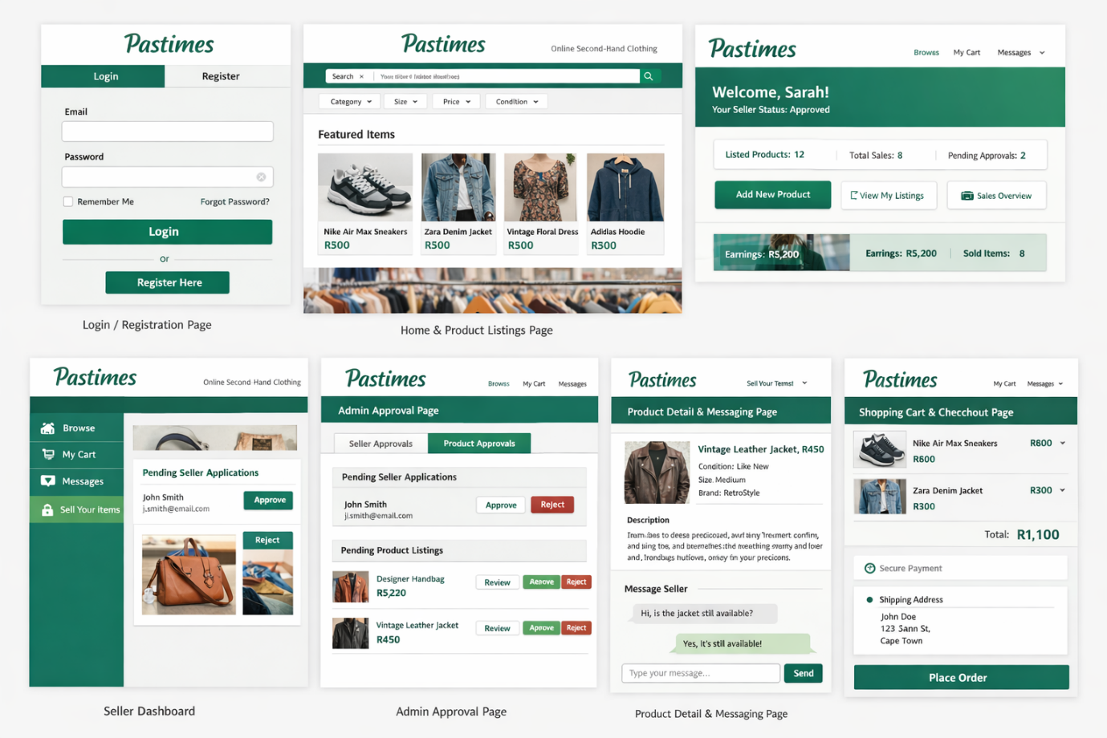
A consistent user experience is provided by the Pastimes web application's multiple major screens. While the home page allows for product browsing and filtering, the login and registration page offers secure user access. Sellers monitor performance and manage listings using the dashboard. Only reputable vendors and high-quality goods are accepted thanks to the admin approval page. The product detail page lets buyers and sellers communicate and offers complete item details. Last but not least, safe shopping is supported by the checkout page and cart. When combined, these screens guarantee system operation, security, and usability for every user on the platform.

Sitemap for Web Application.
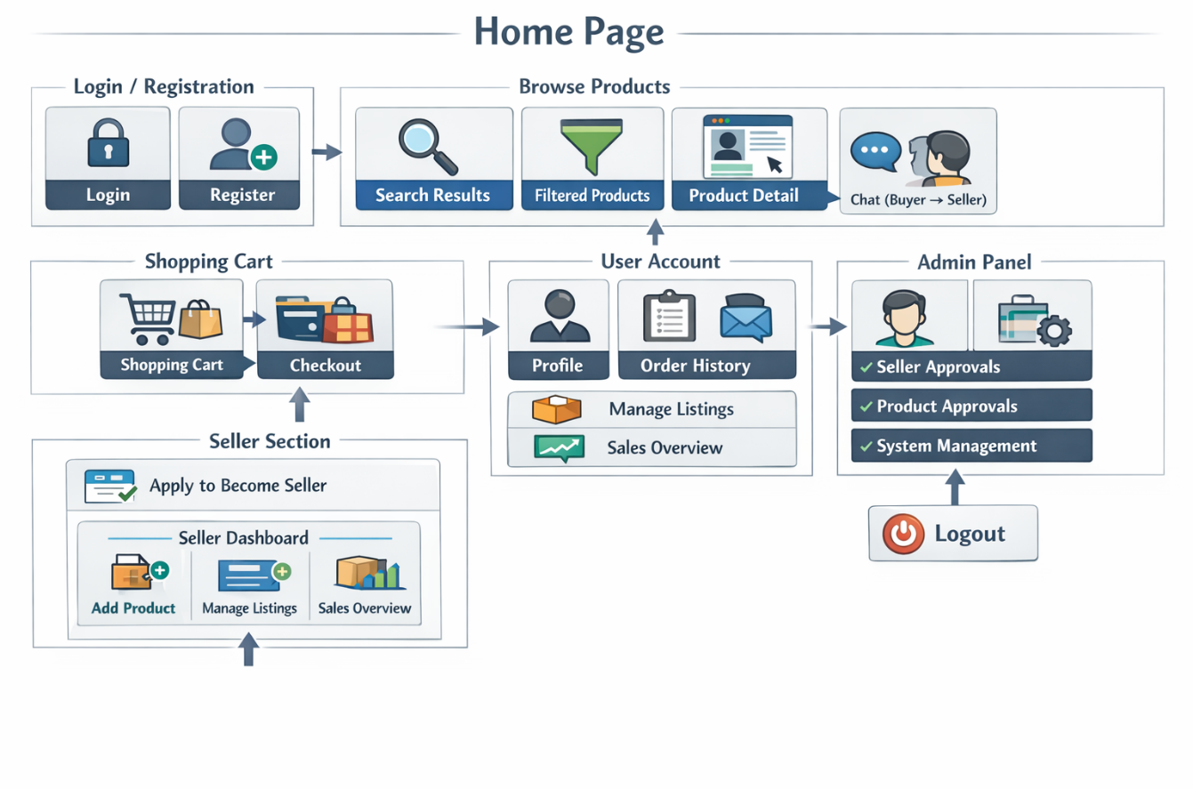

Detailed listing of the data captured from the seller and buyer and store in the MySQL database.
For the online marketplace to run smoothly, the Pastimes web application needs systematic data collecting from both customers and sellers. This information is kept in a MySQL database and is utilized for user communication, transactions, product administration, and authentication. Security, consistency, and effective system performance are guaranteed by proper data design.

Data Captured from Buyers
Buyer Personal Information: Full Name,Email Address ,Password (encrypted) ,Role (Buyer).
Buyer Activity Data: Items viewed ,Items added to cart ,Purchase history ,Messages sent to sellers.
Order Data: Products purchased, Total amount paid, Quantity of items, Order date, payment status.

Data Captured from Sellers:
Seller Registration: Full Name ,Email Address ,Password (encrypted) ,Role (Seller) ,Seller verification status (Pending/Approved/Rejected) , Approval date (admin-controlled)
Product Listing Data: Product ID,Product Name,Description,Brand,Size,Condition (New / Used / Like New),Price.
Seller Performance Data: Number of products listed,Number of sales completed,Messages received from buyers.

Data Captured from Admin
Admin data :Admin ID,Username,Login credentials,Seller approvals,Product approvals/rejections,System activity logs
Messaging System Data: Message ID,Sender ID,Receiver ID,Message content,Timestamp
All users (buyers, sellers, and administrators) are appropriately controlled within the platform thanks to the data gathered in the Pastimes system. In addition to increasing security and system stability, this structured data design makes it possible to track all web application operations effectively.

Actors and their role in the system
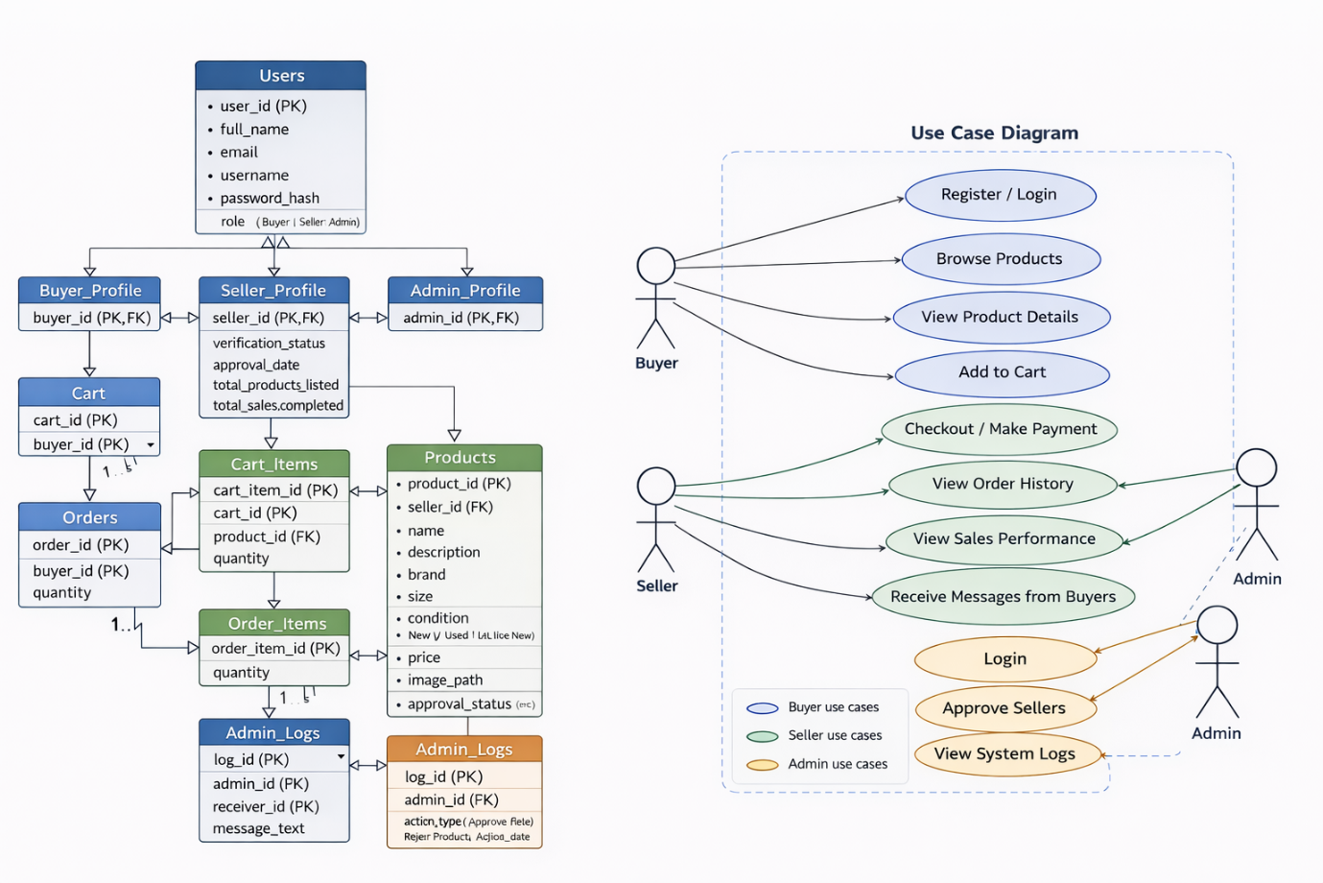

ERD diagram
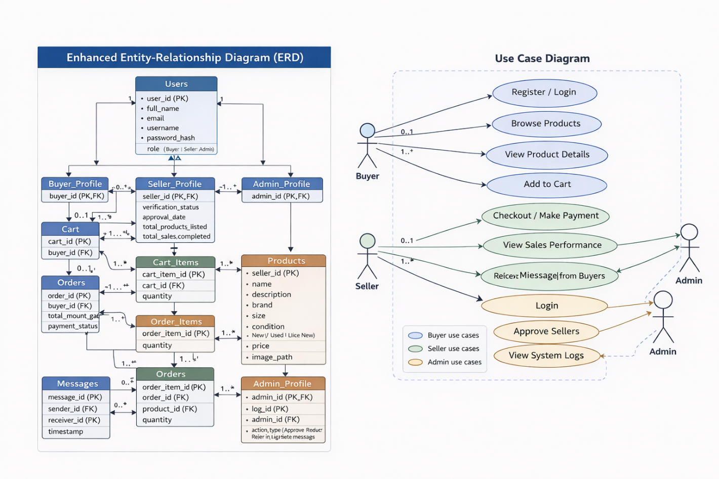

Project plan detailing deadlines and milestones
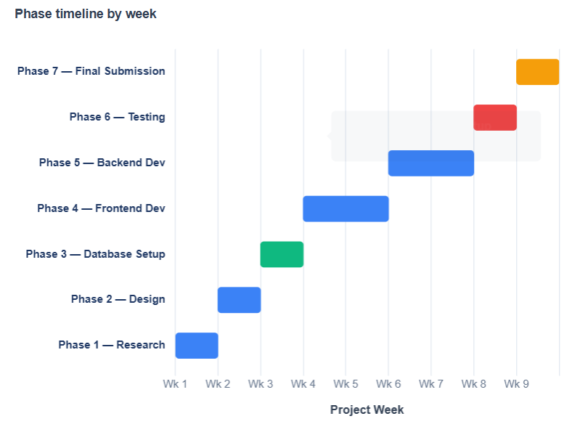
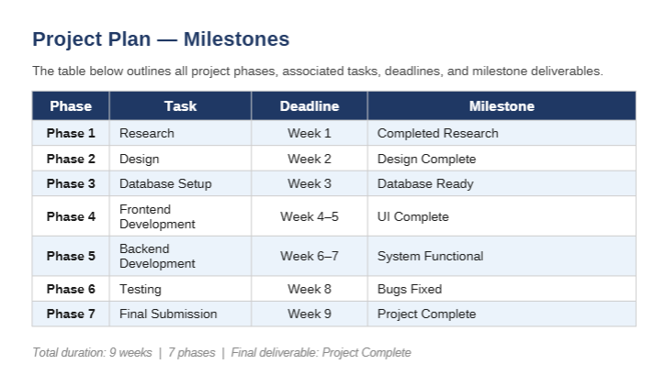

﻿﻿﻿Conclusion
In conclusion, this section has explained the design plan for the Pastimes web application. It ensures that all the important parts of the system are properly planned before development starts. By setting out the system structure, features, user interface, and database needs, a clear plan has been created for building an organised and efficient online marketplace.
This planning process makes sure that both functional and non-functional requirements are considered, especially usability, security, and overall user experience. By using ideas from existing platforms, the system is designed to improve on current weaknesses while still including key features such as safe transactions, user accounts, and product management.
Overall, this design phase provides a strong base for building the Pastimes web application, helping to reduce errors during development and ensuring the final system is easy to use and effective.

References
- Laudon, K.C. and Laudon, J.P., 2020. Management Information Systems: Managing the Digital Firm. 16th ed. Harlow: Pearson.
- Pressman, R.S. and Maxim, B.R., 2020. Software Engineering: A Practitioner’s Approach. 9th ed. New York: McGraw-Hill.
- Seconds To Go, 2026. Online thrift store. Available at: https://secondstogothrift.com (Accessed: 13 April 2026).
- Thrift by Pangape, 2026. Online thrift store South Africa. Available at: https://thrift.pangape.co.za/ (Accessed: 13 April 2026).
- Unsplash, 2026. Free fashion and clothing images. [online] Available at: https://www.unsplash.com (Accessed: 14 April 2026).
- Vakoop, 2026. South African preloved marketplace. Available at: https://vakoop.co.za (Accessed: 13 April 2026).

